LITERATURE SURVEY

Abstract

A web based tool is being planned for therapeutic nutrition prescriptions in clinical settings. The cloud based system would have the ability to calculate the nutritional requirements and to guide first line nutritional management to patients and clients automatically. Also, it serves as an electronic medical and dietetic record, and personalised nutrition consultation approach can be

client can converse to his/ her personal dietitian at their own convenient setting. The implementation once done would invite more and more queries for personalised nutrition support rather than depending on the set menu plans as in the case of current online approaches. Authenticity of the consultant dietitian would also be ensured by the responsible team providing nutrition support.

KEYWORDS: Web Based Tool, Cloud Based System, Electronic And Medical Dietetic Record, Nutrition Support.

INTRODUCTION

Nutritional support is the provision of adequate nutrients to maintain a healthy body weight and avoid malnutrition. The continuous delivery of high-quality and cost-effective nutritional care to patients has been shown to be an increasingly difficult task. It is observed that dieticians are requested to carry out the nutritional assessment, to manually calculate the nutritional needs and to design the everyday meal plan for each patient. In most cases, these time-consuming tasks are not completed due to lack of time or inadequate number of personnel [1]. Development of a computer assisted information tool with cloud-based on-line diet consultation module and comparison of its efficacy with one- to-one counselling would be efficiently utilized for client education intervention programs. The nutrient content calculation was planned to undertake with commonly consumed traditional as well as junk foods in Kerala; and the Indian Food Composition Table [2] was the authenticated support tool, followed by nutrition education software for patient education in hospitals and clinics.

METHODOLOGY

Role of ICTs (Information and communication technologies) in nutrition

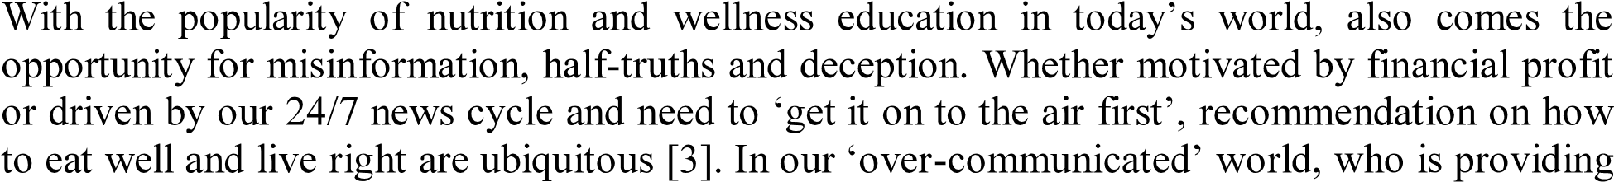

the information is as important as to what information is being provided [4].

Diet consultation tool development

Development of authenticated Clinical nutrition research involves the study of effects of dietary intervention on one or more biological or health-related end points in human participants. Such research is foundational to providing evidence for dietary guidance and public health messaging. Clinical nutrition research is an essential endeavour that provides the evidence based underling dietary requirements and public health messages [5].

Nutritional support is the provision of adequate nutrients to maintain a healthy body weight and avoid under nutrition. Early nutritional support in hospitals has resulted in a positive correlation with the patient's outcome [6]. An accurate dietary intake measurement is important to clarify relationships between dietary intakes and chronic diseases [5]. In most of the therapeutic settings, dietitians are requested to carry out the nutritional assessment, to manually calculate the nutritional

needs and to design the everyday meal plan for each patient. In most cases, these time-consuming tasks are not completed due to lack of time or inadequate number of personnel. Thus, the everyday menus are not individualized and nutritional assessment is performed only for patients with visible signs of malnutrition. Therefore, the nutritional support is not always adequate and efficient. Nutrition care managers have recently realized that the use of information technology improves the quality and effectiveness of the nutritional support services in clinical settings compared with the traditional manual methods. Most of the software that has been developed for hospital Dietetic Departments, concern nutritional screening and assessment, assignment of tasks, distribution of workload among dietitians and data recording [1].

Development of nutrition education software

Nutrition education software enables the dietitian to effectively conduct awareness campaigns (individual as well as community) as visual media has a powerful impact on people [7]. With this in mind, it is planned to develop a CAI tool for lifestyle diseases prevalent in the society.

The proposed tool can be designed & developed as a mobile app for Mobile devices or a web based application for computers. As per latest studies on market, the total users of Android application/Mobile phones across the world has crossed 190 million & one of the fastest growing market for the same is ASIA with 34 million users & growing. This is going to be our target audience. The proposed solution helps a user to make use of on line counselling in a personalized chat room with data recording facility for references. He can plan his diet & modify nutritional inputs as per the nutritional assessments. He can plan the diet with various applications modules integrated in the solution. In the case of mobile app, the users can avail these services as a



made available in the CAI. Provision of chat rooms for live chat can be used with schedule request. Details of appointments & confirmation/ cancellation will happen online.

Cloud based consultation model for personalised nutrition care

Automatic and nutrition requirement generally employed with tools such as computerised systems, mobile based systems and other such technologies which are more personalised and handy to the users. The wireless infrastructure based devices can collect data for long period of time. In cloud computing with its immense computation power for easily deployment of healthcare monitoring algorithms and helps to process sensed data. Cloud computing is one of the new approaches in distributed systems that can handle some of the challenges of smart healthcare in terms of security, sharing, integration and management [8].

The major types of nutrition computer programs pertain to nutrient analysis, food service and recipe management, menu planning [9], clinical nutrition, drug-nutrient interactions, health risk assessment and lifestyle prescription, food and nutrition education and games [10]. In addition to programs specific to their field, nutrition educators are also assisted by general production tools such as graphics packages, computer photo and clip art collections and presentation software. Programs to educate patients provide dietary information and teach about causes of disease, symptoms, complications, dietary management and menu planning. It is expected that the nutrition counselling management system can improve the national health with animated nutrition counselling [11].

1. Proposed Outcome for the cloud based solution in Mobile platform  Customized and easy to access user Interface.

 Can create profile with Setting goals & keeping check points with alarms.  Individual Chat rooms with options of fixing appointments for counseling.

 Offers multiple options available as per the Nutritional assessment  Options of capturing data from counseling session for future references  Counseling for disease oriented diet plans like Ketogenic diet etc.

 Suggest diet plans as per available raw materials.

* + Calorie counter for selected food item  Alternative dish with required calories  Recorded health history.
  + Calorie values of more than 3000+ International & Indian cuisines  Interesting foot notes on selected food items

1. Outlook of the results anticipated

The working model plan of the solution as well as the outlook of the model has been discussed in the diagram given below. A CAI (computer assisted instruction tool) may be modified to desired platform in the given proposal.

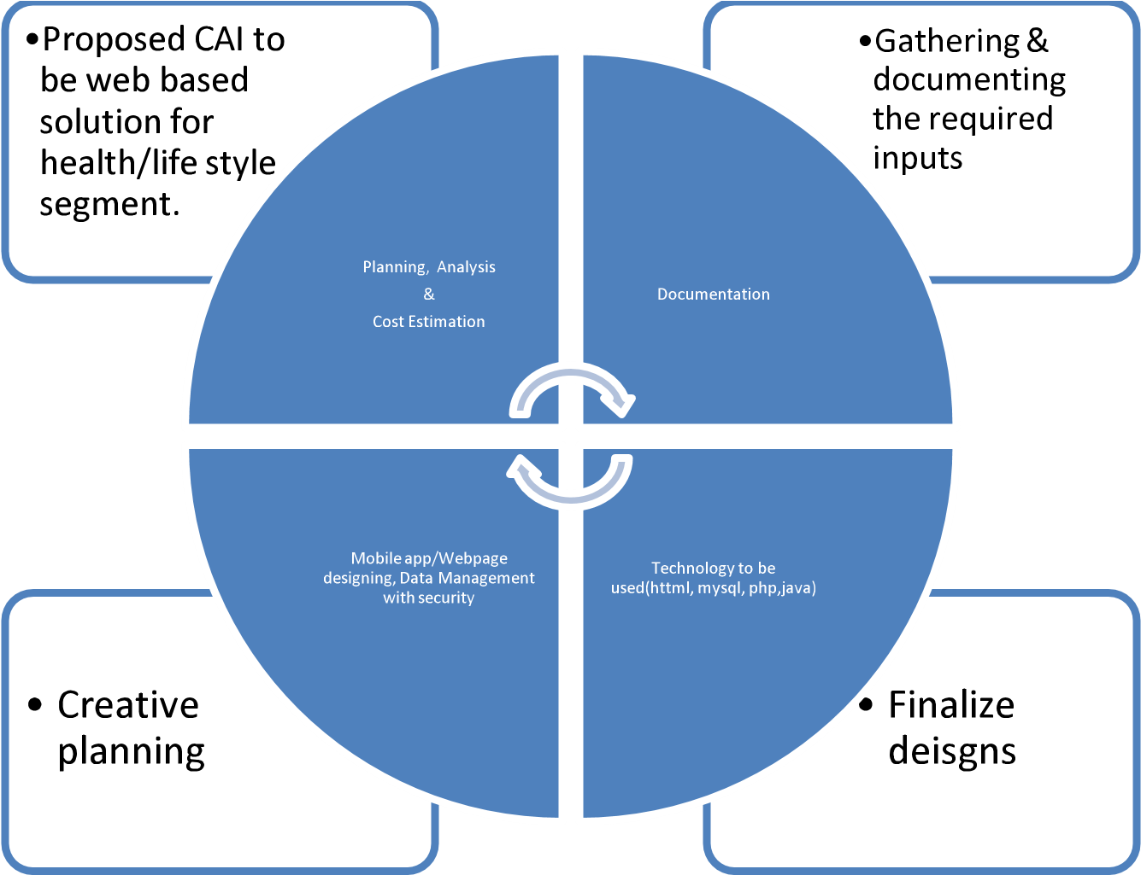

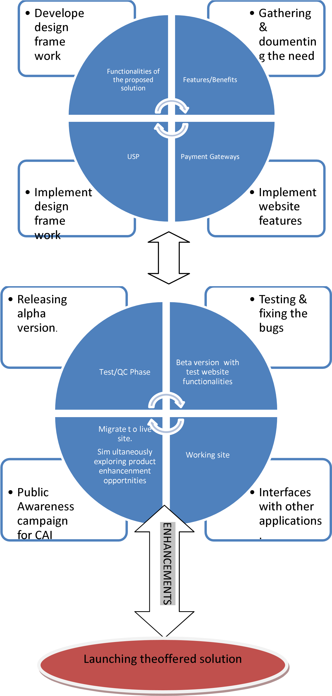

View publication stats